1. M = 10 kg ; x = 2.0 cm ; Find the spring constant.
$$F= -k*x=M*a ; a=gravitaional acceleration= -9.8\frac{m}{s^{2}}$$

$$-k*x=10 kg* -9.8\frac{m}{s^{2}}$$

$$-k*0.02 m=-98 N=> k=\frac{98 N}{0.02 m}$$

$$k= 4,900\frac{N}{m}=49\frac{N}{cm}$$

2. Swinging Pendulum reaches a height of 1.0 m, find minimum speed at the bottom of the swing to reach 1.0 m.

Use energy conservation to calculate; At the bottom of the swing the ball has no Potential Energy, and full Kinetic energy. The ball will have full potential energy and no kinetic energy if the swing ends at a height of 1.0 m (since we need to find the *minimum* speed, aka the ball stops at 1.0 m).

$${KE}_{i}+{PE}_{i}= {KE}_{f}+{PE}_{f}$$

$${KE}_{i}=\frac{1}{2}m{v_{i}}^{2} ; {PE}_{i}=0 ; {KE}_{f}=0; {PE}_{f}=F*d=ma*d ;d=height=1.0 m$$

$$\frac{1}{2} m{v_{i}}^{2}=ma*d=m*9.8\frac{m}{s^{2}}*1.0 m$$

$${v_{i}}^{2}=\frac{2*m*9.8\frac{m}{s^{2}}*1.0 m}{m}$$

$$v_{i}=\sqrt{2*9.8\frac{m}{s^{2}}*1.0 m}=\sqrt{19.6\frac{m^{2}}{s^{2}}}=4.43\frac{m}{s}$$

1. F = ma = 30 N; h = 10 m; v = 13 m/s; Find the avg. force of air friction.

Use energy conservation again. Full potential before it is dropped, full kinetic as it hits the ground. Include the air friction this time though.



$${KE}_{i}+{PE}_{i}= {KE}_{f}+{PE}_{f}$$

$${KE}_{i}=0 ; {PE}_{i}=F*h ; {KE}_{f}=\frac{1}{2}m{v_{f}}^{2}+ F_{friction}*h; {PE}_{f}=0$$

$$F*h=\frac{1}{2}m{v_{f}}^{2}+ F_{friction}*h$$

$$30 N*10 m=\frac{1}{2}m{v_{f}}^{2}+ F_{friction}*h; F=30=ma=>m=\frac{30}{a}=\frac{30}{9.8\frac{m}{s^{2}}}=3.06 kg$$

$$300 J= \frac{1}{2}\left(3.06 kg\right){\left(13\frac{m}{s}\right)}^{2}+ F_{friction}*10 m$$

$$F_{friction}= \frac{300J-258.57 J}{10 m}=4.143 N$$

$m_{1}=4 kg;m_{2}=6 kg; v_{i1}=1.8\frac{m}{s} ; v_{i2}=0.2\frac{m}{s}; v_{f1}=0.6\frac{m}{s} ; v_{f2}=1.4\frac{m}{s};$

Determine whether kinetic energy is conserved:

${(\frac{1}{2}m}_{1}*{v_{i1}}^{2})+{(\frac{1}{2}m}_{2}*{v_{i2}}^{2})$ = ${(\frac{1}{2}m}_{1}*{v_{f1}}^{2})+{(\frac{1}{2}m}_{2}*{v_{f2}}^{2})$

If kinetic energy is conserved, then the collision is elastic, if it is not conserved then the collision is inelastic. The collision would only be perfectly inelastic if the two objects stuck together when they collided.

$(\frac{1}{2}*4 kg*{\left(1.8\frac{m}{s}\right)}^{2})+(\frac{1}{2}*6 kg*{(0.2\frac{m}{s})}^{2})$ = $(\frac{1}{2}*4 kg*{\left(0.6\frac{m}{s}\right)}^{2})+(\frac{1}{2}*6 kg*{(1.4\frac{m}{s})}^{2})$

$(6.48 J)+(0.12 J)$ = $(0.72 J)+(5.88)$

$$6.6 J=6.6 J$$

Since the Kinetic Energy is the same both before and after the collision, the collision is **perfectly** **elastic**.

1. Break the two momentums down into their x and y components, then add those components. We will call the 8 kg object 1, and the 5 kg object 2. Be sure to note whether the direction is negative or positive.

$${v1}_{x}=15\frac{m}{s}*\cos\left(30°\right)=-13 m/s ; {v1}_{y}=15\frac{m}{s}*\sin\left(30°\right)=7.5 m/s$$

$${v2}_{x}=0; {v2}_{y}=-25 m/s$$

The net momentum can be calculated by combining the weight and velocities of the two objects for each component.

$${m_net}_{x}=\left(8.0 kg*{v1}_{x}\right)+\left(5.0 kg* {v2}_{x}\right)=\left(8.0*-13\right)+0=-104\frac{kgm}{s}$$

$${m_net}_{y}=\left(8.0 kg*{v1}_{y}\right)+\left(5.0 kg* {v2}_{y}\right)=\left(8.0*7.5\right)+\left(5.0*-25\right)=-65\frac{kgm}{s}$$

To find the magnitude use the Pythagorean theorem.

$${m_net}_{mag}=\sqrt{{{v_net}_{x}}^{2}+{{v_net}_{y}}^{2}}=\sqrt{{(-104)}^{2}+{(-65)}^{2}}=122.6 \frac{kgm}{s}$$

To find the angle, use trigonometric identities (it might help to draw it out) 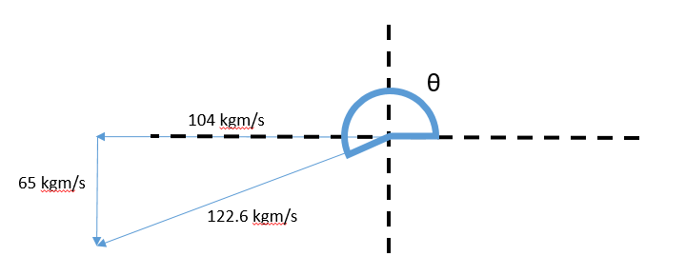

17) First I’m going to derive this thoroughly so you can understand it completely, then we can move through it more quickly to prep for the test.

Given: l = 12 m; FL = 400 N; θ = 51 $°$**;** FM = 874 N; XM = 7.8 m; XL= 6.0 m; XW = 12.0 m; Find the coefficient of static friction between the floor and the ladder.

This is a net force problem with a lot of components, so it is helpful to draw it out.

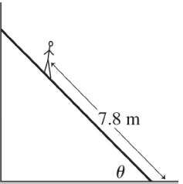

51 $°$

FWall = ? N

FFric = µ $*$ FGround N

FGround = ? N

FL = 400 N

FM = 874 N

6.0 m

Since the ladder is just starting to slip, we need to calculate where the net force of the system has just reached 0. In this case, the force of the wall (FWall) will equal the force of the static friction (FFric), and the force that the ground exerts (FGround) will balance out the weights of the Man (FM) and the Ladder (FL).

The force of the static friction is equal to the static coefficient of the ground multiplied by the force that the ground exerts on the ladder, which is why FFric = µ $*$ FGround N. Since we know that the maximum force that that FFric can apply to balance out the FWall has just been reached (it is just starting to slip), we get:

$$F_{Wall}=F_{Fric}=µ*F_{Ground}=µ*1274 N$$

Now for the ladder to slide, it means that the FWall needs to overcome the FFric to push the ladder to the right. What force is causing the wall to push on the ladder? That’s right, its torque! To find the force of the torque at the end of the ladder, we need to consider the point at which the ladder meets the ground to be the point of the rotation, and the forces being applied by the weights of the man and the ladder to be the forces applying the torque. The equation for Torque is simple, since it is just a type of work:

$$τ=f*d$$

HOWEVER, the tricky part is realizing that the force used in Torque is only the force that is perpendicular to the ladder. Since the ladder is at a 51 $°$ angle, we need to take this into account, since the force applied by gravity is NOT perpendicular to the ladder. Reorienting the picture makes it a little easier to see that we need to apply only the force that is perpendicular to the ladder:

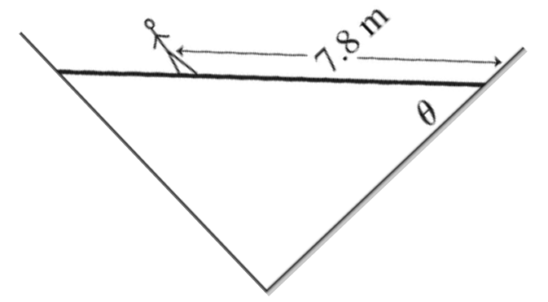

39֯

51֯

39֯

FL = 400 N

FM = 874 N

39֯

51֯

51֯

FWT

FWall

6.0 m

51֯

39֯

FLT

FMT

It is important to note that FWall is only one component of the Force applied to the wall by the Torque (FWT). This is because the force of the Torque that is applied to the wall is at an angle –perpendicular to the ladder. Similar to the ground, the wall applies a force that is perpendicular to it, which pushes the ladder away. To calculate the force of the Torque that the ladder applies to the wall, we need to determine the force that is perpendicular to the ladder. We can calculate the perpendicular forces that are relevant to the torque using trig identities:

$$F_{MT}=F_{M}*\cos\left(51°\right)=874*\cos\left(51°\right)=550.0 N$$

$$F_{LT}=F_{L}*\cos\left(51°\right)=400*\cos\left(51°\right)=251.7 N$$

Since (FWT) is the force that the wall exerts to counterbalance the force of the torque from the man and the ladder, it is equivalent to the forces of the torque from the combined FMT and FLT forces. We can now determine the FWT by calculating the Torque at the wall:

$F_{WT}=\frac{T_{W}}{X_{W}}$, where TW is the Torque at the wall, and XW is the distance from the pivot to the wall.

$$T_{W}=F_{MT}*X_{M}+F_{LT}*X_{L}=\left(550.0 N*7.8 m\right)+\left(251.7 N*6.0 m\right)=5800.2 J$$

Since we now know the Torque that occurs at the wall, we can derive the force applied perpendicularly to the ladder at the wall:

$$F_{WT}=\frac{T_{W}}{X_{W}}=\frac{5800.2 J}{12.0 m}=483.35 N$$

Once we have determined the value of FWT, it is easy to find the value for FWall using trig identities.

$$F_{Wall}=\frac{F_{WT}}{\cos\left(39°\right)}=\frac{483.35 N}{\cos\left(39°\right)}=621.96 N$$

Now going back to the beginning:

$F_{Wall}=F_{Fric}=µ*F_{Ground}=µ*1274 N=621.96 N$, so

$$µ=\frac{621.96N}{1274 N}=0.49$$

Test Prep:

Now that we have derived it the hard way, let’s do it the simple way, since you won’t have an hour to do the problem on the test.

TWall



TLadder

TMan

FWall = ? N

51 $°$

FFric = µ $*$ FGround N

FGround = ? N

FL = 400 N

FM = 874 N

6.0 m

Find the value for FGround:

Find the value for FWall in terms of the Friction Coefficient µ:

$$F_{Wall}=F_{Fric}=µ*F_{Ground}=µ*1274$$

Find the value for TWall in terms of the Torque applied to the wall by the Ladder, from a pivot point where the ladder meets the ground:

$$T_{Wall}=T_{Man}+T_{Ladder}={[cos\left(θ\right)*F}_{M}*X_{M}]+{[cos\left(θ\right)*F}_{L}*X_{L}]$$

Now find TWall in terms of FWall:

Combine these two values of TWall:

, or

$$F_{Wall}=\frac{{[cos\left(θ\right)*F}_{M}*X_{M}]+{[cos\left(θ\right)*F}_{L}*X_{L}]}{\sin\left(θ\right)*X_{W}}$$

Now just plug and chug:

$$F_{Wall}=\frac{[cos\left(51\right)*874*7.8]+[cos\left(51\right)*400*6]}{\sin\left(51\right)*12}=622$$

Finally, solve in terms of the friction coefficient µ:

$$F_{Wall}=F_{Fric}=µ*F_{Ground}=µ*1274=622$$

$$µ=\frac{622}{1274}=0.49$$